Steps to Install & Configure KeyCloak on Ubuntu

Before starting

Change hostname

using below command:
hostname set-hostname keycloak.bontonsoftwares.com

check your local ip using
ip addr command

then enter the ip address in the below path with domain name/ host name

cat /etc/hosts

once done check whether the ip is resolving or not

hostname --ip-address

Step 1: Update the System.

apt-get update

Step 2: Install Java.

apt-get install default-jdk

Check Java version.
java -version

Step 3: Download & Install KeyCloak.

cd /opt/
wget https://github.com/keycloak/keycloak/releases/download/15.0.2/keycloak-15.0.2.tar.gz

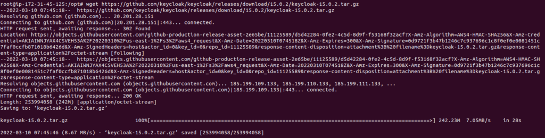

tar -xvf keycloak-15.0.2.tar.gz

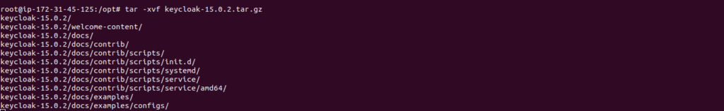

mv keycloak-15.0.2 keycloak

Create a user and group.

groupadd keycloak
useradd -r -g keycloak -d /opt/keycloak -s /sbin/nologin keycloak

Provide the Ownership permission.

chown -R keycloak: keycloak
chmod o+x /opt/keycloak/bin/

Step 4: Configure the KeyCloak.

cd /etc/
mkdir keycloak

Copy the following configuration files.

cp /opt/keycloak/docs/contrib/scripts/systemd/wildfly.conf /etc/keycloak/keycloak.conf
cp /opt/keycloak/docs/contrib/scripts/systemd/launch.sh /opt/keycloak/bin/

Provide the ownership permission.
chown keycloak: /opt/keycloak/bin/launch.sh

Open the launch.sh config file.

vim /opt/keycloak/bin/launch.sh

Edit the following line:

WILDFLY_HOME="/opt/keycloak"

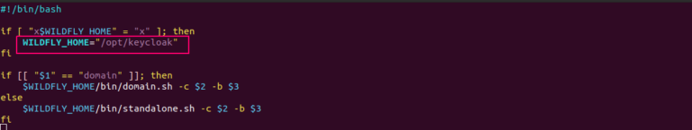
Save the file.
Step 5: Create a Systemd Service File.

Copy the file.

cp /opt/keycloak/docs/contrib/scripts/systemd/wildfly.service /etc/systemd/system/keycloak.service

Open the keycloak.service file.
vim /etc/systemd/system/keycloak.service

Update/Edit the following lines:

[Unit]
Description=The Keycloak Server
After=syslog.target network.target
Before=httpd.service

[Service]
Environment=LAUNCH_JBOSS_IN_BACKGROUND=1
EnvironmentFile=/etc/keycloak/keycloak.conf
User=keycloak
Group=keycloak
LimitNOFILE=102642
PIDFile=/var/run/keycloak/keycloak.pid
ExecStart=/opt/keycloak/bin/launch.sh $WILDFLY_MODE $WILDFLY_CONFIG $WILDFLY_BIND
StandardOutput=null

[Install]
WantedBy=multi-user.target

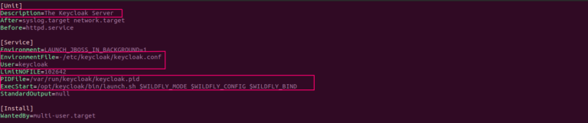
Reload,Enable & Start the keycloak service.

systemctl daemon-reload
systemctl enable keycloak
systemctl start keycloak

Check Keycloak Status.
systemctl status keycloak

Here is the command output.

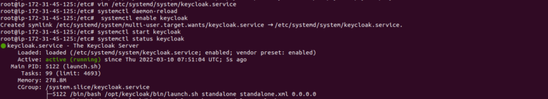
Check the Keycloak server log.
tail -f /opt/keycloak/standalone/log/server.log

Here is the command output.
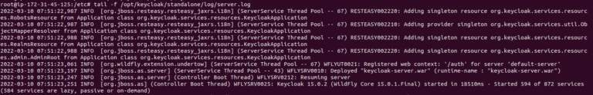
Step 6: Create an Admin User for Keycloak./

opt/keycloak/bin/add-user-keycloak.sh -u admin

Set the Password.
- Here is the command output.
Restart the Keycloak service.
systemctl restart keycloak

To disable the HTTPS for Keycloak.

/opt/keycloak/bin/kcadm.sh config credentials --server http://localhost:8080/auth --realm master --user admin

NOTE: instead of localhost provide your local ip or hostname

ex:

/opt/keycloak/bin/kcadm.sh config credentials --server http://keycloak.bontonsoftwares.com:8080/auth --realm master --user admin

Provide the admin password.

Bonton-123
Run the following command to disable the HTTPS.
/opt/keycloak/bin/kcadm.sh update realms/master -s sslRequired=NONE

Step 7: Open the KeyCloak web interface
http://server-ip:8080

Here is the command output.

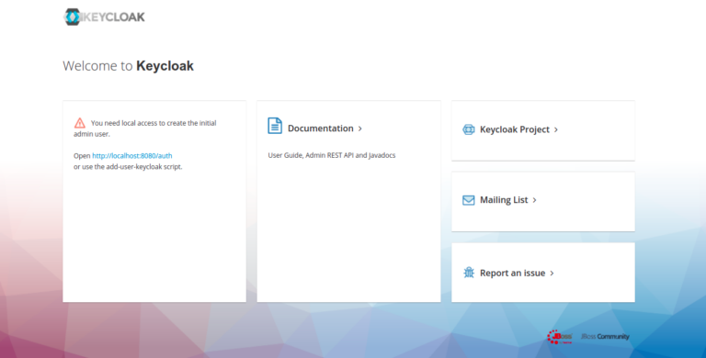

Open the Login web interface.
http://server-ip:8080/auth/admin

Here is the command output.
Provide the Username & Password.
Click on Sign In.
